hi

Final Examination (SOLUTION)
(Fall, 2000-2001)

ENGG 201 - Behaviour of Liquids, Gases and Solids

December 13, 2000 Time Allowed: 180 minutes.

- Attempt all six (6) questions. Weighting as noted. Total marks = 100.
- The textbook and electronic calculators are permitted. Notes are not allowed.
- Print your name clearly in the space provided on the cover page. Write your ID No. on the last page and all other pages in the provided space.

Surname: ____________________ Given Name(s):______________________ Section* ______

*L01 for MWF Lectures (Dr. Maini);
L02 for T R Lectures (Dr. Azaiez).

STUDENT IDENTIFICATION
Each candidate must sign the Seating List confirming presence at the examination. All candidates for final examinations are required to place their University of Calgary student l.D. cards on their desks for the duration of the examination. (Students writing mid-term tests can also be asked to provide identity proof.) Students without an l.D. card who can produce an acceptable alternative l.D. e.g. one with a printed name and photograph, are allowed to write the examination.
A student without acceptable l.D. will be required to complete an Identification Form. The form indicates that there is no guarantee that the examination paper will be graded if any discrepancies in identification are discovered after verification with the student's file. A Student who refuses to produce identification or who refuses to complete and sign the Identification Form is not permitted to write the examination.

EXAMINATION RULES
(1) Students late in arriving will not normally be admitted after one-half hour of the examination time has passed.
(2) No candidate will be permitted to leave the examination room until one-half hour has elapsed after the opening of the examination, nor during the last 15 minutes of the examination. All candidates remaining during the last 15 minutes of the examination period must remain at their desks until their papers have been collected by an invigilator.
Question  No. | Maximum  Mark | Mark  Obtained
I | 20
II | 15
III | 20
IV | 15
V | 15
VI | 15
Total (out of 100)

(3) All inquiries and requests must be addressed to supervisors only.
(4) Candidates are strictly cautioned against:
(a) speaking to other candidates or communicating with them under any circumstances whatsoever: (b) bringing into the examination room any textbook, notebook or memoranda not authorized by the examiner;
(c) making use of calculators and/or portable computing machines not authorized by the instructor: (d) leaving answer papers exposed to view;
(e) attempting to read other student's examination papers.

The penalty for violation of these rules is suspension or expulsion or such other penalty as may be determined.
(5) Candidates are requested to write on both sides of the page, unless the examiner has asked that the left hand page be reserved for rough drafts or calculations.
(6) Discarded matter is to be struck out and not removed by mutilation of the examination answer book.
Problem I: (20 points)
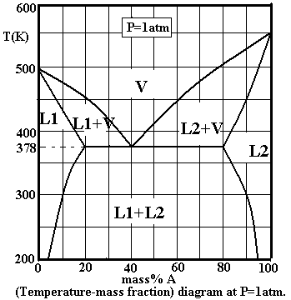
Consider the following liquid-vapour phase diagram for two components A and B.

The molar masses of A and B are:
M_{A}=45kg/kmol,
M_{B}=40kg/kmol.

- Use the diagram to determine the normal boiling points of A and B. (1 mark)

T_{A}=550K
T_{B}=500K

2- Label on the diagram all the phase regions. (2 marks)

See diagram.

3- Consider a mixture consisting of 70wt% of A. The mixture has a mass of 3kg and is held at a temperature T=450K.
  - What are the phases present and their compositions? (2 marks)

Phase | Composition (wt% of A)
Vapour  Liquid (L2) | 60%  90%

  - What is the mass of each of the phases you reported in question (a)? (4 marks)

Use Lever rule:
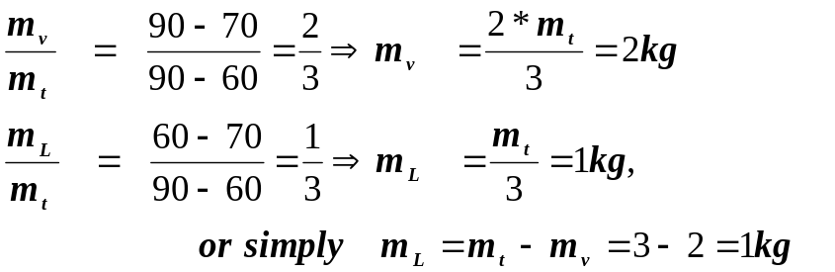

4- Consider a new mixture, which is 90wt% A and 10wt% B. The total number of moles in the mixture is equal to 22.5 moles.
- What is the mass of this mixture? (3 marks)

n_{t}=n_{A}+n_{B}= (m_{A}/M_{A}) +(m_{B}/M_{B})=(w_{A}*m/M_{A} +w_{B}*m/ M_{B})=m*( w_{A}/M_{A} +w_{B}/ M_{B})

==> m = n_{t} /( w_{A}/M_{A} +w_{B}/ M_{B})= = 0.0225kmol/(0.9/45 +0.1/40)=1kg

Mass of the mixture: 1kg

- What are the masses of A and B in the mixture? (1 mark)
m_{A}= w_{A}*m= 0.9kg
m_{B}= w_{B}*m= 0.1kg

- What is the boiling temperature of this mixture? (1 mark)
T= 450K

- Determine the composition of the first bubble that forms at the boiling temperature of the mixture. (1 mark)
Composition of bubble (wt% of A): 60%

- The mixture is held at a fixed temperature equal to its boiling temperature, and B is gradually added until all the mixture has become vapour. Determine the mass of B added. (3 marks)

The mixture is all in vapour form ==> w_{A}=0.6

w_{A} = m_{A} /(m +m_{added})
0.6 = 0.9/(1 +m_{added}) ==> m_{added} = 0.5kg.

Mass of B added: 0.5kg

- The resulting mixture is cooled down to a temperature T=378K. Determine the phases present at this temperature and their compositions. (2 marks)
Phase | Composition (wt% of A)
Liquid (L1)  Liquid (L2)  Vapour | 20%  80%  40%

Problem II: (15 points)
A gas storage tank is filled with a gas mixture containing 802 kg methane, 1,100.25 kg CO₂, and 751.75 kg ethane. The temperature and pressure in the tank are 25 ºC and 7.25 MPa respectively. The critical properties of these components are listed below.
Component | Molar Mass  kg/kmol | T_{c}  K | P_{c}  atm | ω
Methane | 16.04 | 190.6 | 45.4 | 0.008
CO₂ | 44.01 | 304.2 | 72.8 | 0.225
Ethane | 30.07 | 305.4 | 48.2 | 0.098

Calculate the volume of the tank using:
(a) The ideal gas law. (3 marks)
(b) The pseudo critical point method with the generalized compressibility chart. (6 marks)
  - The Pitzer-Curl Method. (6 marks)

Solution:
(a) Moles of methane = 802 kg/(16.04 kg/kmol) = 50 kmol
Moles of CO₂ = 1100.25 kg/(44.01 kg/kmol) = 25 kmol
Moles of ethane = 751.75 kg/(30.07 kg/kmol) = 25 kmol
→ Total number of moles = 100 kmol
Using the ideal gas law
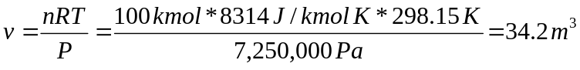 → v≈34.2 m³

(b) The first step is the calculation of pseudo-critical properties. Mole fractions of individual components are obtained by dividing their number of moles by the total number of moles.
Component | x_{i} | T_{ci} (K) | x_{i}T_{ci} | P_{ci} (atm) | x_{i}P_{ci} | ω_{i} | x_{i}ω_{i}
CH₄ | .5 | 190.6 | 95.3 | 45.4 | 22.7 | 0.008 | 0.004
CO₂ | .25 | 304.2 | 76.05 | 72.8 | 18.2 | 0.225 | 0.056
C₂H₆ | .25 | 305.4 | 76.35 | 48.2 | 12.1 | 0.098 | 0.025
Summations |  |  | 247.7 |  | 53 |  | 0.085

T_{pc} = 247.7 K:, P_{pc} = 52.95 atm; ω_{pc} =0.085
T_{r} = 298.15/247.7 = 1.20
P_{r} = 7,250,000/(52.95 * 101325) = 1.35
Z (from chart) = 0.72
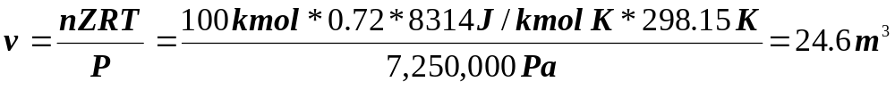 → v≈24.6 m³
(c) Pitzer and Curl method
At T_{r} = 1.2 and P_{r} = 1.34, values of Z⁽⁰⁾ and Z⁽¹⁾ are: Z⁽⁰⁾ = 0.704
Z⁽¹⁾ = 0.121
→ Z = 0.704 + 0.085 * 0.121 = 0.714
→v≈24.4 m³
Problem III: (20 points)
A vessel contains a two-phase (vapour and liquid) mixture of butane, pentane and hexane at 21 ºC. The mole fraction of butane in the vapour phase is 0.35. The liquid phase contains 45 mol% pentane. Some useful properties of these components are provided in the following table.

Component | Vapour pressure at 21 ºC  atm | Temperature at which  P_{v} = 2 atm, ºC
Butane | 2.14 | 18.8
Pentane | 0.58 | 58.0
Hexane | 0.17 | 93.0

- Under the specified conditions, what is the number of remaining degrees of freedom? (2 marks)
- Assuming that the system obeys Raoult’s law, calculate the pressure in the vessel. (10 marks)
- Calculate the vapour pressure of pentane at 45 ºC. (8 marks)

(a) F = C + 2 - P =3 + 2 – 2 = 3
Degrees of freedom already used = 1 for T, 1 for y₁, and 1 for x₂, i.e. total of 3.
Remaining degrees of freedom = 0

(b) Raoult’s law states:
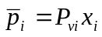

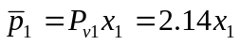
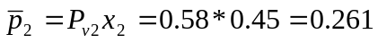

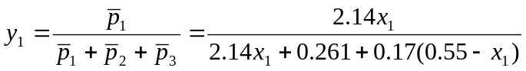

The value of y₁ is given to be 0.35, therefore,

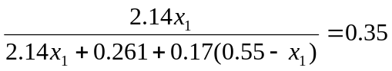

Solve for x₁ to get x₁ = 0.0856.
x₃ = 1 – 0.0856 – 0.45 = 0.464

Now that the mole fractions are known in the liquid phase, the partial pressures can be determined.

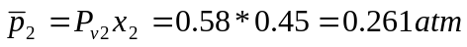

The pressure in the vessel is equal to the sum of all partial pressures.

P = 0.183 + 0.261 + 0.079= 0.523 atm.

Estimating the vapour pressure at 45 ºC, requires developing a relationship between P_{v} and T from the available information.

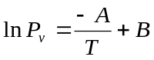
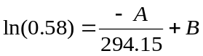
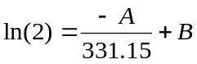
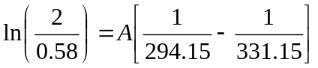

A = 3259
B = 10.53

At 45 ºC:

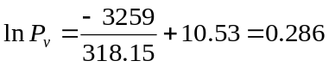

P_{v} = 1.33 atm

Problem IV: (15 points)
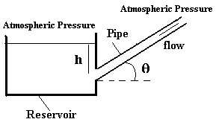
A steel pipe of length L=10m and diameter D=10cm, is connected to a reservoir containing a fluid of viscosity μ=5*10⁻² Pa.s and density ρ=10³ kg/m³.

The reservoir is very large so that we can assume that the height h of the fluid in the reservoir remains constant and equal to 5m.

- Show that the Reynolds number in the pipe is equal to 2000*u, where u is the average velocity. (1 mark)
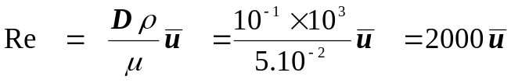

- Use Bernoulli equation between the free surface of the liquid in the container and the pipe entrance to show that the pressure at the entrance of the pipe is equal to: P_{b} +ρgh –ρu²/2, where P_{b} is the atmospheric pressure and u is the average velocity in the pipe. (3 marks)

Bernoulli equation between the free surface (0) and the pipe entrance (1):
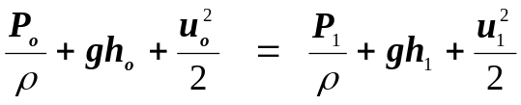
But P_{o}=P_{b}, u_{o}=0 and u₁=u ➔ 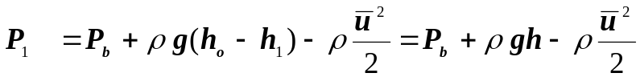

- Initially the pipe is horizontal (θ=0º). Determine the average velocity in the pipe. (6 marks)
N.B. Assume that the flow is turbulent.

θ=0º
P₂ = P_{b} ➔ ΔP =( P₂-P₁) = -ρgh +ρu²/2
Δh = h₂-h₁= 0 (Horizontal pipe)
➔ -( ΔP+ ρgΔh) = ρgh-ρu²/2

But: -( ΔP+ ρgΔh) = 2f u² ρL/D ➔ ρgh-ρu²/2 = 2f u² ρL/D

➔ (f +D/4L)u² = ghD/(2L)

➔ (f+0.0025)u² = 0.245

The above equation is solved by trial and error:

f=0.004 ➔u²=0.245/(f+0.0025)=37.692→u=6.139m/s ➔Re=2000u=12279 ➔(Chart):f≈0.009

f=0.009 ➔u²=0.245/(f+0.0025)=21.304→u=4.615m/s ➔Re=2000u= 9231 ➔(Chart):f≈0.0092

f=0.0092 ➔u²=0.245/(f+0.0025)=20.940→u=4.576m/s ➔Re=2000u= 9152 ➔(Chart):f≈0.0092

Therefore:
u ≈ 4.58m/s
Re ≈ 9160 > 4000 (turbulent flow)

- The inclination of the pipe is gradually increased. Determine the angle θ at which the flow in the pipe becomes laminar. (5 marks)

Flow is laminar ➔Re=2100 (2000).
➔ u=Re/2000 = 1.05 m/s (1m/s).
Between the pipe entrance and exit:
ΔP = -ρgh +ρu²/2
Δh = h₂-h₁= Lsin(θ)
➔ -( ΔP+ ρgΔh) = ρg[h- Lsin(θ)]-ρu²/2

But: -( ΔP+ ρgΔh) = 32μLu/D² ➔ ρg[h- Lsin(θ)]-ρu²/2 = 32μLu/D²

➔ sin(θ) = -32μ u/(ρgD²) -u²/(2gL) +h/L
=-16.31x10⁻³ u –5.1x10⁻³ u² +0.5

➔ sin (θ) = 0.4773 (0.4786).

➔ θ = 28.51º ( 28.60º).

Problem V: (15 points)
(a) Starting from the heat conduction equation (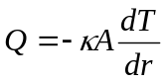), derive the following expression for heat flow through the walls of a hollow sphere of inside radius r₁ and outside radius r₂. The sphere is heated to a uniform inside temperature of T₁ and the outside temperature is T₂ and the thermal conductivity of the wall material is κ.
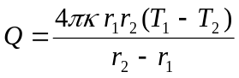 (7 marks)
Note: The surface area of a sphere is given by: 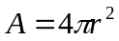.
(b) Show that when the wall thickness of a spherical enclosure (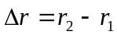) is very small compared to the two radii (r₁ ≈ r₂ ≈ r), the above equation becomes equivalent to the heat transfer equation for a flat plate geometry. (4 marks)
(c) A large spherical vessel 0f 0.005 m wall thickness is protected on the outside with a 0.05 m thick layer of an insulating material. The wall of the sphere is maintained at a uniform inside and outside temperature of 120 ºC and 20 ºC respectively. The thermal conductivities of the wall material and the insulating material are 50 W/mK and 5.0 W/mK respectively. Assuming that the thickness of the composite wall is small compared to the inner radius of the sphere, calculate the temperature at the meeting point of the steel and the insulation. (4 marks)

Solution
(a) 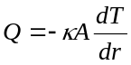 and . Therefore, 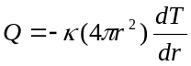
Separating the r and T terms: 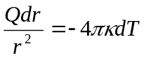. Integrating both sides, 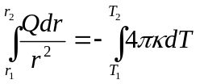
The limits of intergration are r₁ to r₂ on the L.H.S., and T₁ to T₂ on the R.H.S. This gives:
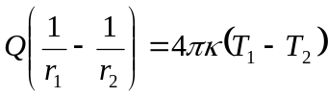 or,

- When 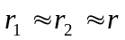, the above equation becomes
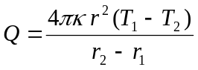. Substituting and 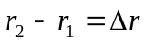, the equation becomes
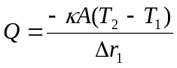, which is the equation for a flat plate geometry.

- The same amount of heat flows per unit area through both layers, therefore:

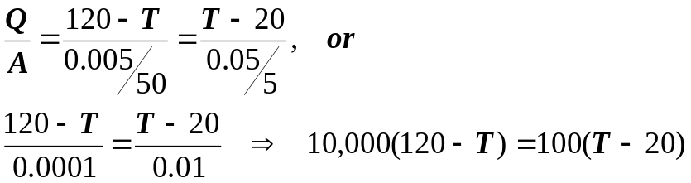
or T = 119 ºC
Problem VI: (15 points)
The Buckingham potential gives a better representation of short-range repulsive forces between molecules than the Lennard-Jones model. For the Buckingham model, the potential function is given by:

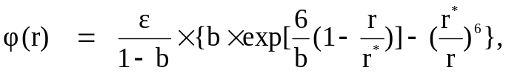
where ε, b and r* are constant parameters.
- Determine the expression of the force associated with this model. (5 marks)

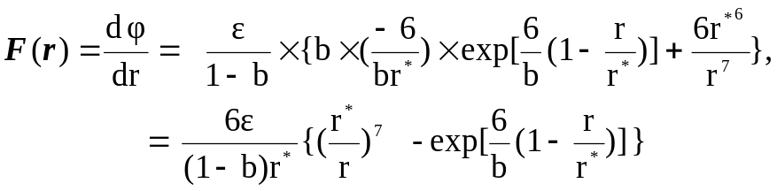

- Determine the equilibrium separation distance r_{o} for this model in terms of r*. (5 marks)
The equilibrium separation distance r_{o} is the distance where F(r) =0:

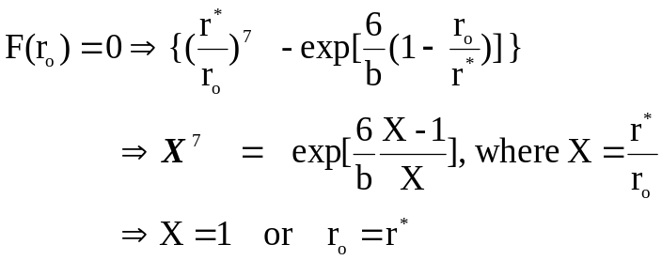

- Show that -ε is the value of the potential at r=r*. (5 marks)

